**METU – EEE**

Middle East Technical University – Electrical Electronics Engineering Department

**PROJECT REPORT**

*by* Serhat ÖZKÜÇÜK

within the scope of the course

**EE568**

**SELECTED TOPICS ON ELECTRICAL MACHINES**

*by* Dr. Ozan KEYSAN

2019 – 2020 Spring Semester

**PROJECT REPORT NO** : 04

**PROJECT NAME** : PM Motor Comparison Analysis

**ASSIGN / DUE DATE** : 03.06.2020 / 28.06.2020 , 23:59

Literature Review

In this study, 1kW permanent magnet synchronous machine (PMSM) type servo motor design aspects are discussed. In this concept, several comparative designs are modelled with FEA performance considerations. Servo motors are essential machines in industrial applications and have a basic specific property as high torque with low inertia (sausage type machine) for acceleration, speed, position accuracy and robust performance. Providing the basic properties depends on machine parameters such as diameter of the rotor-stator, pole-slot number, slot dimension, winding types, permanent magnet type etc. Design of these parameters effect the magnetic and electric load distribution, air gap flux density distribution (harmonic contents), flux leakages, cogging torque, end winding losses, thermal performance, machine dimension and cost [1].

The first critical consideration for designing AC PMSM servo is magnet type, location and shape in the rotor structure. There are two types PMSM servo known as internal permanent magnet synchronous machine (IPMSM), and surface mount permanent magnet synchronous machine (SMPMSM). The main difference between them the IPMSM can produce extra reluctance torque with hard manufacturing process. The detailed comparative performance analysis of the two type machines under identical conditions in terms of air gap flux density distribution, back EMF and current waveforms is critical for design process. IPMSM has more harmonics in its air gap flux density waveform than SMPMSM, which is caused by the rotor openings and the smaller air gap. Back EMF wave forms of the two type machines at the rated speed have nearly same amplitude. However, there are more harmonics components in the IPMSM, which are caused by the more harmonic air gap flux density components. The harmonic components of armature currents are slightly higher for the SPMSM with respect to IPMSM, which is due to the lower inductances. IPMSMs are superior in costs while SPMSMs are more robust, with higher overall efficiency and cooling performance [2,3]. Magnet shaping is another critical performance indicator. Sinusoidal shaped magnets provide low cogging torque and more sinusoidal back-emf waveform. If magnets have radial bottom, peaks on the back-emf waveform can be reduced [4].

Loading field on the machine is another critical consideration for PM servo machine design process. After determining the machine loadings (magnetic, electrical), the geometrical structure must be designed for homogenous flux distribution. According to phase current increasing under specific load, fundamental magnitude of the tooth flux (generated by PM) must decreases for preventing excessive magnetic loading [jintao chen]. Winding configuration is another performance parameter for PM servo machines. Concentrated winding type stators provides the lower volume of copper used in end windings than distributed winding types [5].

Cogging torque is another problematic issue for PM servo designs. Cogging torque can be produced by rotor pole and stator slot coupling caused or manufacturing tolerances (non-uniform air gap, tolerances of PM, lamination, magnetization direction, slot or pole positions). Stator slot skewing, rotor pole skewed, closed slot, pole width changes and slot opening shifting are most common methods for decreasing the cogging torque, also improving manufacturing sensitivity is another solution [6,7].

These considerations are basic critical design issues. Also, there are some performance improvement systems with help of control structures. Fault tolerant machines are another research concept for servo system. Tuning the machine or detection the disturbance and acting to fix it is important work for industrial servo systems. Modifying the stator winding or adding extra redundant winding to stator can provide an advantage to tolerate the winding faults or detection the some critical data measurement for control system [8].

1. Analytical Calculations & Sizing

In this project, we design a AC PMSM type servo with respect to following specifications:

**The application:** Industrial servo systems

**The type of the machine:** Permanent magnet synchronous machines (PMSM), surface mount type.

**Power, voltage and current ratings:**  1kW, 220V - 4A (nominal for 1 phase), (3 phase inverter ratings: DC level of bulk is 310V (from 220V AC rms), 190Vph-ph, 3.1Aph, Y connected)

**Operating conditions:** 600 rpm rated speed at 400W (3000rpm max), 4Nm rated torque (12Nm max. torque), Duty type:S1 (Continuously), Natural cooling, IP 54 Enclosure (industrial applications), 0-55’C ambient temperature.

**Limitations (if there is any) such as mass, diameters, cost, efficiency:** max. mass 6kg, low inertia for obtaining dynamic response so the dimensions will not exceed the motor length L_max=250mm, outer diameter Do_max=125mm. (The smaller it can be designed, the better.)

**Design Procedure (Analytically)**

Machine constant: $P_{mech out}=C_{mech}D^{2}Lf_{syn}$

Where, $P_{mech out}$ is output power, $D^{2}L$ is represents the rotor volume, $f_{syn}$ is synchronous frequency and $C_{mech}$ machine constant is :

$$C_{mech}=\frac{π^{2}}{2}k_{w}\overline{A}\overline{B}$$

Where, $k_{w}$ is winding factor, $A$ is electric loading and $B$ is magnetic loading.

$${\overline{A}}_{\left(\frac{A}{m}\right)}=\frac{N_{turn per slot}IQ}{πD_{i}} , {\overline{B}}_{(T)}=\frac{pφ_{pole}}{πD_{i}L}$$

Where, $N_{turn per slot}$ is turn number per slot, $I$ is current flow through wire, $Q$ is slot number, $D_{i}$ is inner diameter, $L$ is length of bore, $p$ is pole number, $φ_{pole}$ is flux per pole.

If we assume the iron core material for stator and rotor we can select the max magnetic loading as 1.88T (1.2T for average) which is saturation limit for selected material. Selection of electric loading depends on the required torque level.

$$Torque=π×D_{i}×L×σ_{Ftangential_{average}} \left(x\right)×r_{rotor}=4Nm$$

Where, $σ_{Ftangential_{average}} (x)$ is tangential stress at x distance (will be rotor edge), $r_{rotor}$ is radius of the rotor.

$$σ_{Ftangential}\left(x\right)=\overline{B}\sin\left(x\right)\overline{A}sin(x)$$

$$σ_{Ftangential_{average}} \left(x\right)=0.5×\overline{A}\overline{B}$$

According to specification of our motor the rated torque is 4Nm (12Nm max.) at rated output power 1kW. Also, max outer diameter is 125mm, so rough calculation (using $D_{o}/D_{i}$ table with respect to the worst case pole number 2) we can select the rotor diameter as nearly half of outer diameter 60mm (considering air gap, outer cover etc.). Determination of the axial length $L$ of the machine can be estimated by using again rough definition of aspect ratio for servo motors as $\frac{L}{D}≫1$ (Torque-Aspect ratio graph from METU EE568 courses – Machine Design Basics, page 35), we can select the $\frac{L}{D}=2$. At this time $L$ will be 250mm. The air gap can be selected as 1mm for providing mechanical reliability.

If we combine the known parameters up to now:

$$Torque=π×0.06×0.25×0.5×\overline{A}×1.2×0.03=4Nm$$

The average electrical loading will be 4715 A/m, (4.715 kA/m).

$$P_{mech out}=\frac{π^{2}}{2}k_{w}\overline{A}\overline{B}D^{2}Lf_{syn}=1kW, f_{syn}=50Hz , k_{w}=0.79$$

The air gap can be selected as 1mm for providing mechanical reliability. The slot and conductor number can be determined as (nominal current from spec is 4A):

$${\overline{A}}_{\left(\frac{A}{m}\right)}=\frac{N_{turn per slot}IQ}{πD_{i}}=4715=\frac{N_{turnperslot}×4Q}{π×0.06}→ {Q×N}_{turnperslot}=222.18 total cond.$$

According to these calculations we know that the total conductor number in the stator. So we can determine possible pole-slot combinations with respect to our winding factor result using the table 1.

**Table 1:** Winding factors for different combinations of pole and slot numbers and double layer winding (METU EE568 courses – Airgap & Mechanical constraints, page 42)

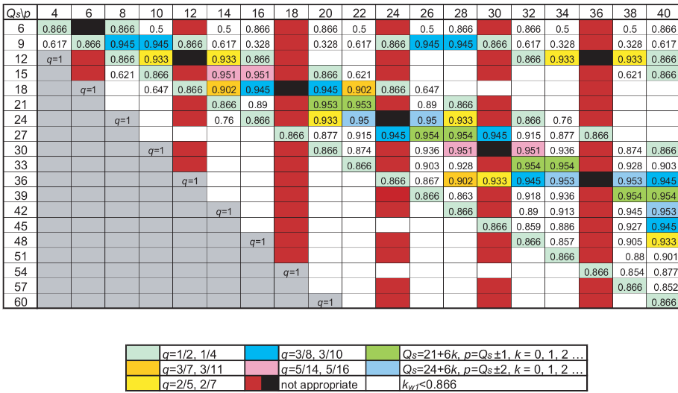

For determining the slot number $Q$, we can use the formula as follows and determine the $q$ value which is slot per pole per phase. Where the $m$ is phase number, $p$ is pole number. For improving the smooth torque performance we can select the $q$ as fractional.

$$Q=m×p×q$$

If we select a suitable conductor which can carry 4A current from AWG table, the #20 conductor (area: 0.518mm2) is suitable for our design. But, the machine max torque will be 12Nm (3xNominal torque) so, we must select the conductor which is capable of carry 12A max. current. This is the #14 conductor for safe design (area: 2.08mm2). We can assume the slot fill factor 60%.

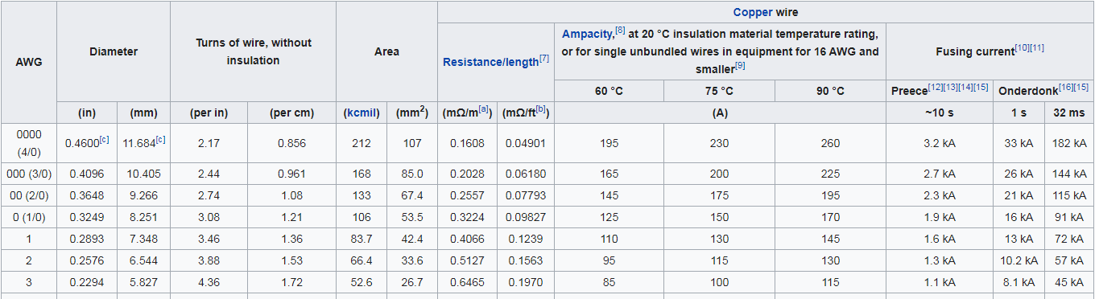



**Fig. 1 :**AWG table and selected conductor.

If we create a table which is shown the possibility of the design and mechanics with respect to fig. 3, we can obtain table 2.

**Table 2:** Design mechanics control table for different pole slot selection.

|  |  |  |  |  |  |
| --- | --- | --- | --- | --- | --- |
| Pole number | Slot Number | Winding factor | N turn per slot | Slot area* mm2 | Possibility |
| 4 | 6 | 0.866 | 37 | 470 | OK – 135 turn/slot |
| 10 | 12 | 0.933 | 18.5 | 236 | OK-68 turn/slot |
| 16 | 18 | 0.945 | 12.33 | 157 | OK-45 turn/slot |
| 20 | 21 | 0.953 | 10.57 | 134 | OK-38 turn/slot |

*slot area is calculated roughly with respect to rectangular parallel teeth and slots. Slot height is assumed 20mm (back core 10mm). Slot number calculation is done with taking the mid-point of slots. Slot fill factor 60%. Single conductor area is 2.08mm2.

From the table 2, all possibilities are reliable when back core is 10mm. So according to flux density distribution and saturation we can increase the back core or if back core flux density is under the saturation level, we can increase the rotor diameter (preventing leakage) or decrease the machine dimension (decreasing slot height). The rotor diameter is 60mm (circumference:18.84cm). If we placed 10 magnets on the rotor, we have 1.8cm place for each of them. It is the most suitable design because magnet size is bigger than 1cm (it is possible to find from the market). So we can select the 10 pole 12 slot machine for implementation. 4 pole 6 slot machine has low winding factor so there will be much more harmonics. 16 pole or 20 pole machine implementation can be hard because magnet size will be lower than 1cm (brittle magnets).

If the assume slots gets wider with diameter slots (rectangular teeth), the d ratio can be assume as 0.7. This means that the slot height is:

$$d=0.7=\frac{60mm}{85.7mm}→slot height=12.85mm$$

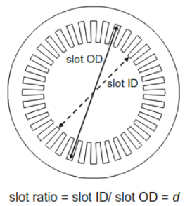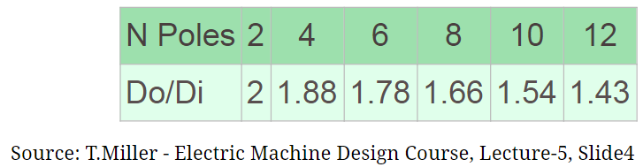

**Fig. 2 :** d ratio on the machine and Do/Di design guide

According to design table of T.Miller (fig. 2), the outer diameter Do is:

$$for 10 pole machine→\frac{D_{o}}{D_{i}}=1.54, D_{i}=60mm, which yields$$

$$D_{o}=92.4mm, Back core=3.7mm$$

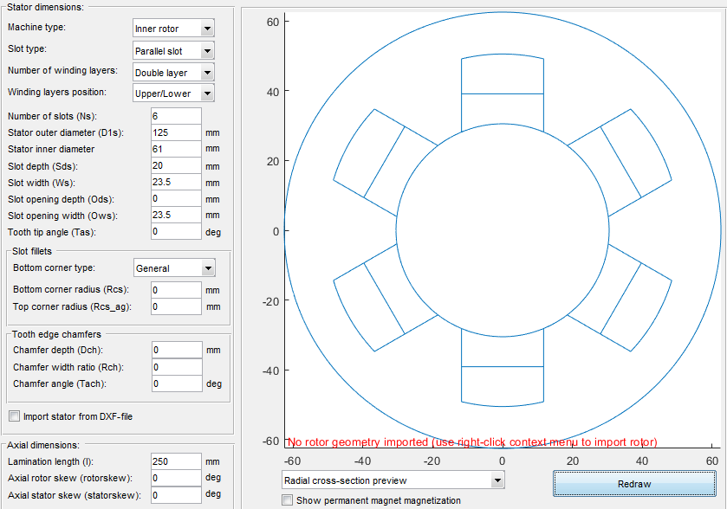 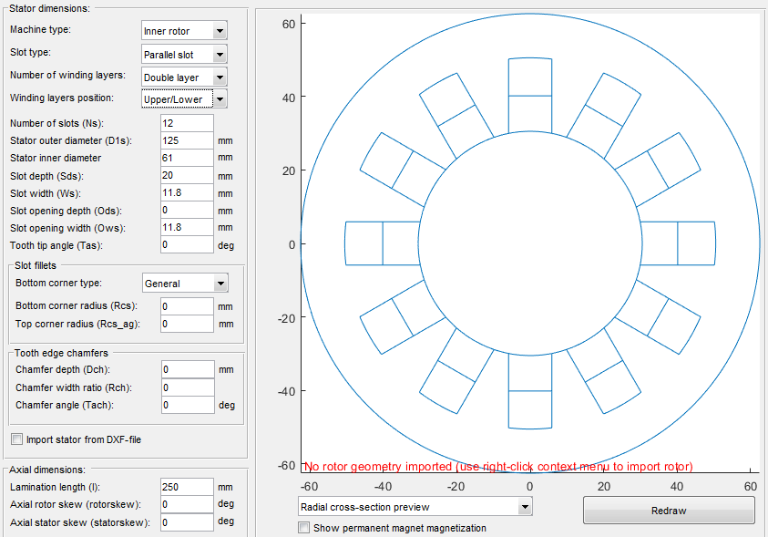

(a) 4 pole 6 slot, 0.866 winding factor (b) 10 pole 12 slot, 0.933 winding factor

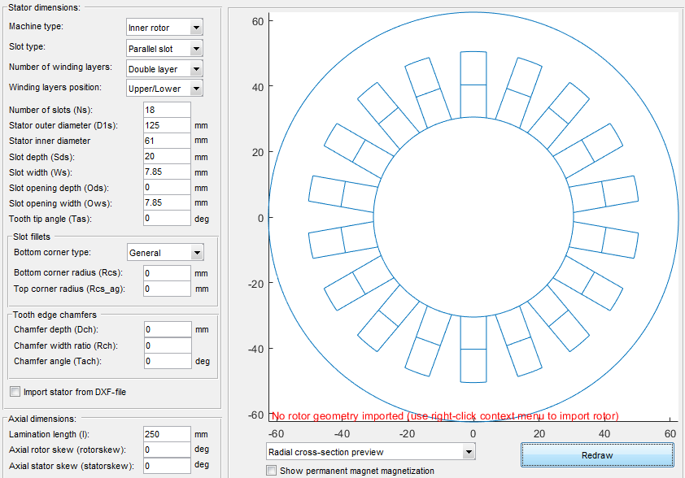 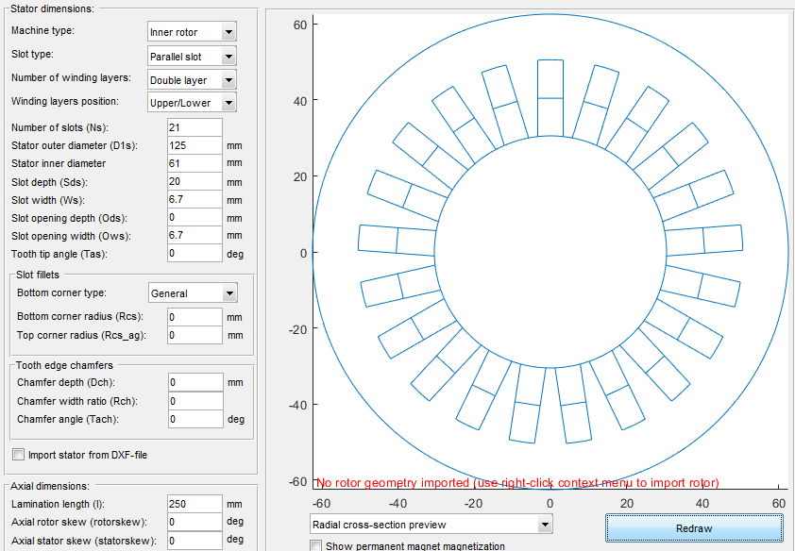

(c) 16 pole 18 slot, 0.945 winding factor (d) 20 pole 21 slot, 0.953 winding factor

**Fig. 3 :** Possible slot dimensions, back core thickness, stator slot design mechanics.

Material selection is another issue for design. If we calculate the flux density from the selected magnetic loading data as follows: (Assuming 10 pole machine)

$${\overline{B}}_{(T)}=\frac{pφ_{pole}}{πD_{i}L}=1.2=\frac{10φ_{pole}}{π×0.06×0.25} , φ_{pole}=0.00565 Wb/m^{2}$$

We can determine the magnet flux density $B_{m}$ as follows:

$$φ_{total}=pφ_{pole}=B_{m}×A_{m}$$

Where $A_{m}=2π{(r}_{rotor}+magnet thickness)×L$ is area of the magnets which is assumed the magnets are separated the rotor surface (magnet thickness is assumed as 5mm).

$B_{m}$ will be 1.02T. According to this value we can select the magnet as N42 neodymium, under 40oC operating temperature with permeance coefficient 4, as shown in fig. 4.

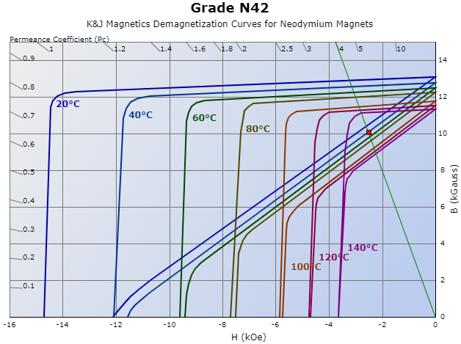

**Fig. 4 :** Load line on the B-H characteristic of the given Neodymium magnet, Permeance Coefficient (Pc): 4, B: 10.08 kilogauss, H: -2.52 kilooersted, |BH|: 25.39 mega-gauss-oersted

The electrical parameters of the design can be selected as 3.1Aph (max 190V phase voltage) for Y connected machine. Total conductor number was 222.18 that is calculated previously so total length of the conductor will be $222×L×2=111m$. The selected AWG14 conductor has 8.286mΩ/m resistance. So the phase resistance will be $\frac{8.286×111}{3}=306mΩ.$ Rated speed of the machine will be $n_{rated}\left(rpm\right)=\frac{120f}{p}=600rpm$ at 50Hz with pole number 10.

Analytically designed machine is given in table 3.

**Table 3:** Analytically designed machine parameters.

|  |  |  |  |
| --- | --- | --- | --- |
| **Pole number $p$** | 10 | **Slot height** | 12.85mm |
| **Slot number $Q$** | 12 | **tooth width** | 9.1mm |
| **Winding factor $k_{w}$** | 0.933 | **Back core** | 3.7mm |
| **Slot /phase/pole $q$** | 2/5 | **Magnet** | N42@40C, 1.008T |
| **Outer diameter $D_{o}$** | 92.4mm | **Flux per pole $φ_{pole}$** | 5.65x10-3 Wb/m2 |
| **Inner diameter** | 60mm | **Phase Voltage,Current** | 190V,3.1A, 600rpm |
| **Air gap** | 1mm | **Phase resistance** | 306mΩ,AWG14 |
| **Axial length** | 250mm | **Power, Torque** | 1kW, 4Nm(12Nm max) |

2. FEA Modelling

Analytically designed machine in part 1, is simulated in this part using Motor Analysis Software (FEA), MotorXP-PM. The constructed geometry is given in fig. 5.

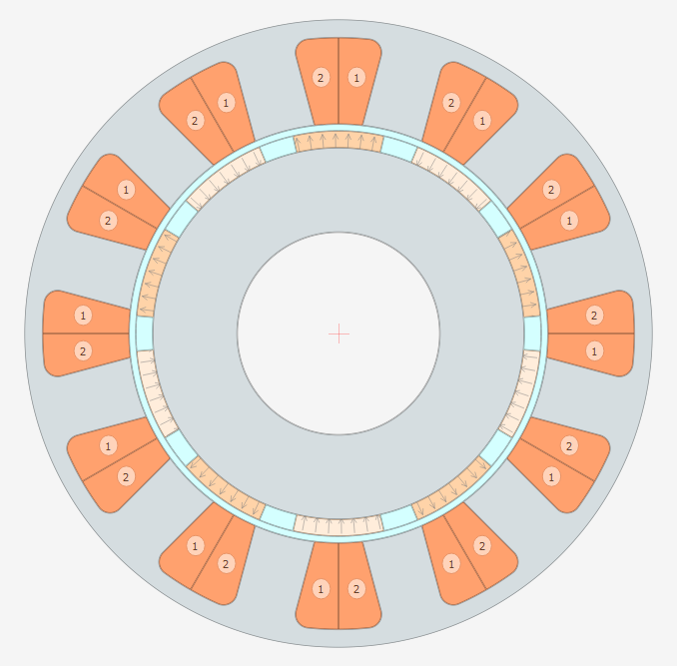

**Fig. 5:** FEA model of the designed machine in Motor Analysis Software MotorXP-PM

The FEA model is constructed with respect to calculations in part1 and obtained table 3. Machine slot configuration is selected as parallel tooth and layer orientation is selected as left/right to prevent the skin effect and flux saturation. Magnets are located on rotor surface (SMPMSM) because easy production and high performance (details are in literature review part) (fig. 6.).

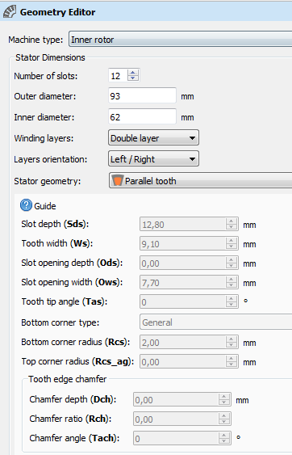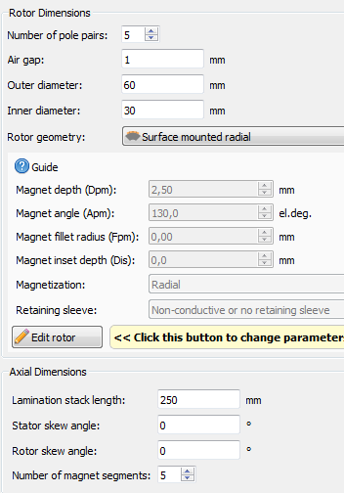

**Fig. 6:** Stator and rotor geometry details.

Stator and rotor materials are selected as M-19 lamination steel and magnet type are N42 neodymium. The conductors are copper. Total machine weight is 7.68kg with respect to designed geometry and material selection as shown in fig. 7.

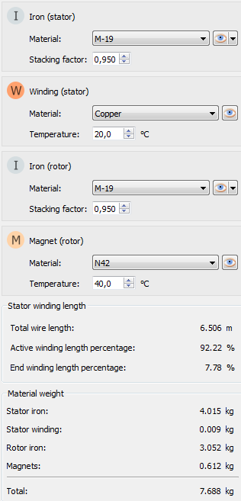

**Fig. 7:** Selected materials for stator, rotor, magnets with suitable stacking factors and weights of the materials and machine.

The machine slot per phase per pole was 2/5 fractional slot. So the winding configuration of the machine is given in fig. 8. AWG#14 conductor is selected for this design and slot fill factor is assumed 60%. Totla conductor number was 222 and 18.5~19 conductor is located per slot. Winding factor was calculated as 0.933. According to our calculation phase resistance without considering end windings was 306mΩ. If we consider the end windings the phase resistance will be 341mΩ as shown in fig. 8. Meshing the machine is given in fig. 9 for FEA analysis.

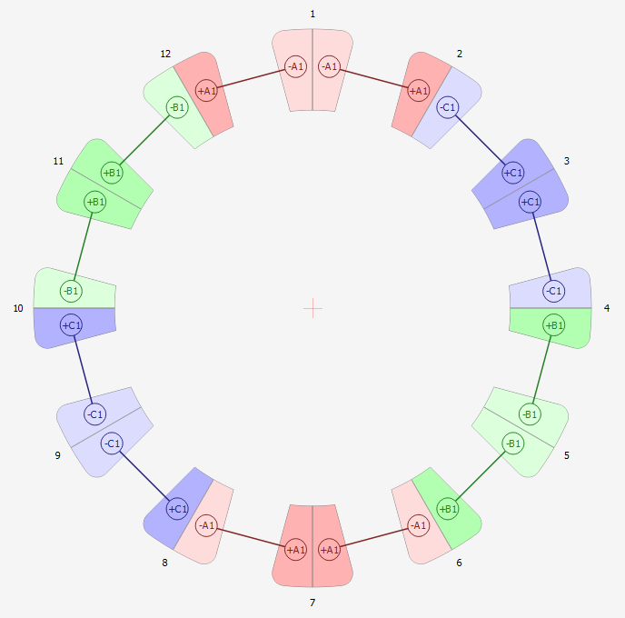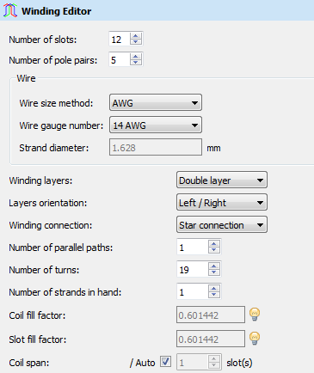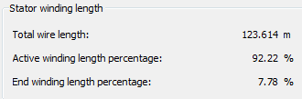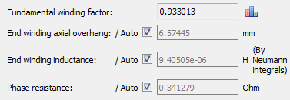

**Fig. 8:** Winding configuration of designed machine

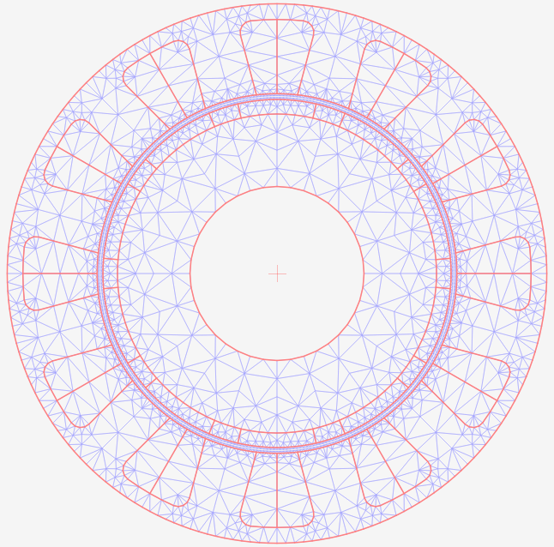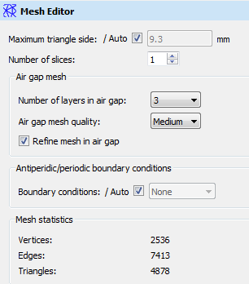

**Fig. 9:** Meshing the design for FEA result

The drive parameters of the design are given in fig. 10. Space vector PWM drive method is selected with 10kHz switching and IGBT switches (IRG4PC50FD_IGBT). The DC bus voltage is set as 310V (rectified 220AC).

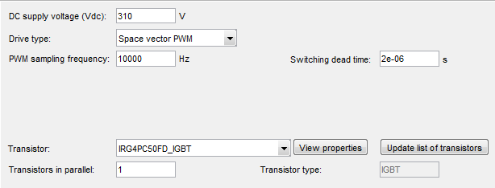

**Fig. 10:** Driver settings of the machine

**FEA Analysis Results**

Design is driven under rated parameters (rated torque 4Nm, rated speed 600rpm). The electrical and magnetic results are given in fig. 11 - fig. 15.

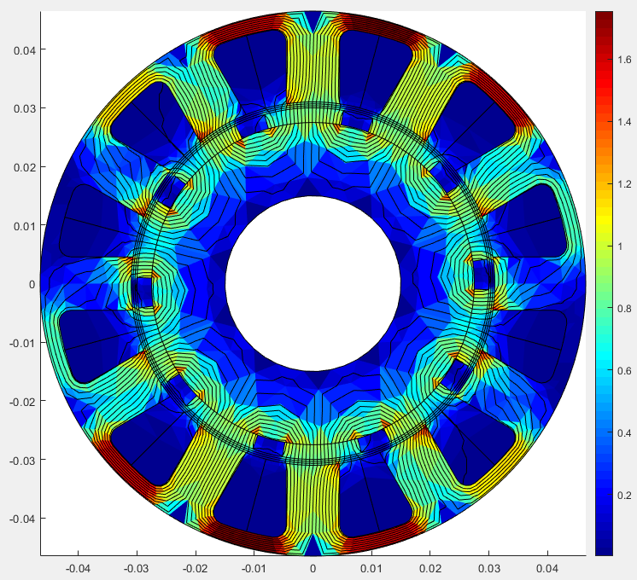

**Fig. 11:** Magnetic flux density distribution

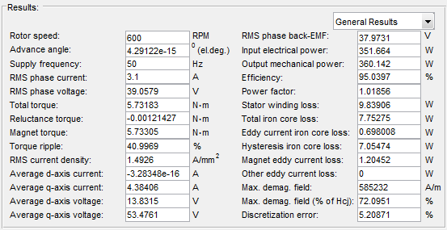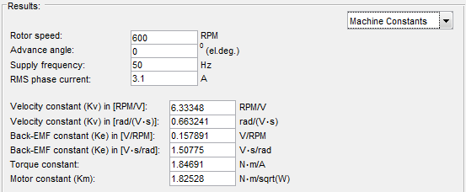 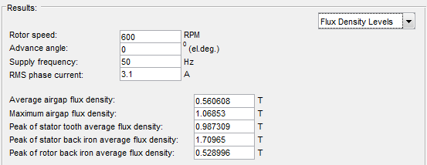

**Fig. 12:** Simulation results, electrical, machine constants, flux density levels

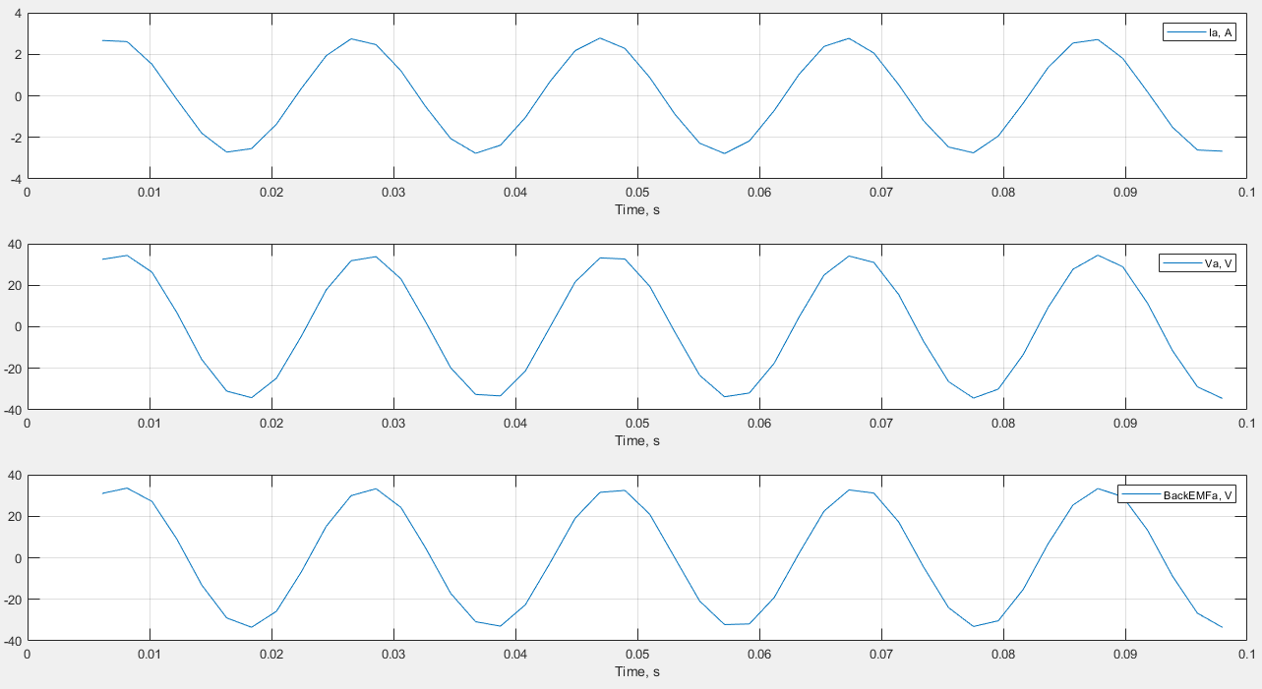

**Fig. 13:** Phase A current, Voltage and Back EMF

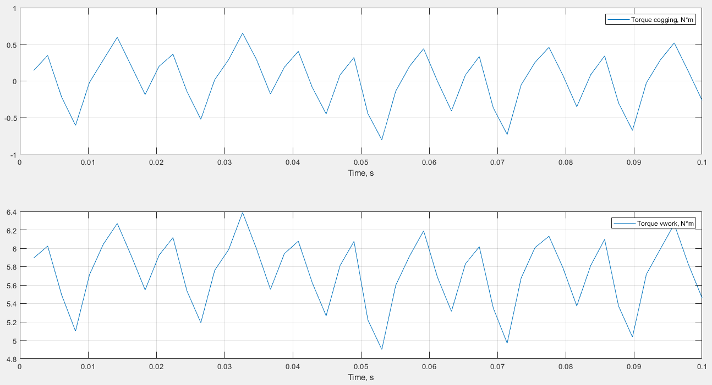

**Fig. 14:** Cogging torque and Electromechanical torque

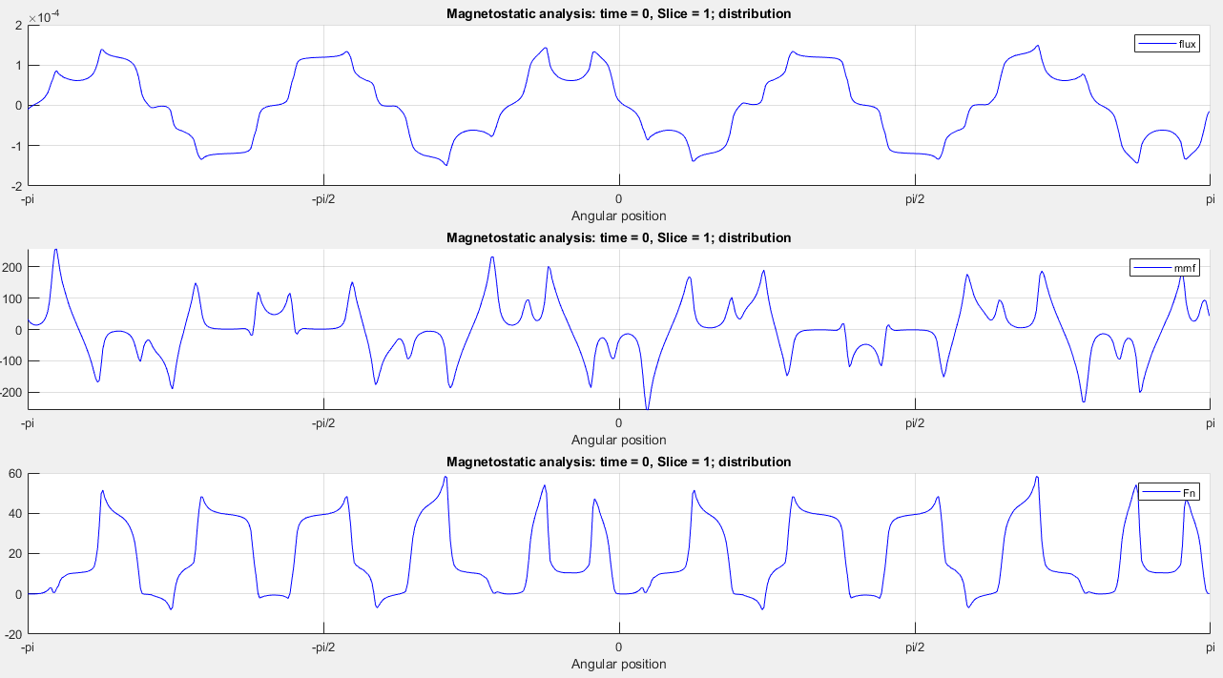

**Fig. 15:** Air gap magnetic flux distribution (Wb), MMF waveform and radial force distribution (N)

**Design Improvements – Stator Slot Smoothing**

As shown from the flux distribution, the back core thickness is not sufficient for saturation. Also slot openings corners have near of the saturation level flux density (torque ripple is 40%). So, the machine will be improved by mean geometrically. The electrical results and performance is acceptable for required specification data. Revised geometry and results are in fig.16-fig. 21.

Rotor dimension is suitable. So we must change slot height and tooth width. The revised d ratio can be assumed as 0.75. This means that the slot height is:

$$d=0.75=\frac{60mm}{80mm}→slot height=10mm$$

According to design table of T.Miller (fig. 2), the outer diameter Do is:

$$for 10 pole machine→\frac{D_{o}}{D_{i}}=1.54, D_{i}=60mm, which yields$$

$$D_{o}=92.4mm, Back core=6.2mm$$

**Table 4:** Analytically revised designed machine parameters

|  |  |  |  |
| --- | --- | --- | --- |
| **Pole number $p$** | 10 | **Slot height** | 10mm |
| **Slot number $Q$** | 12 | **tooth width** | 8mm (fill f.~ 0.8) |
| **Winding factor $k_{w}$** | 0.933 | **Back core** | 6.2mm |
| **Slot /phase/pole $q$** | 2/5 | **Magnet** | N42@40C, 1.008T |
| **Outer diameter $D_{o}$** | 92.4mm | **Flux per pole $φ_{pole}$** | 5.65x10-3 Wb/m2 |
| **Inner diameter** | 60mm | **Phase Voltage,Current** | 190V,3.1A, 600rpm |
| **Air gap** | 1mm | **Phase resistance** | 306mΩ,AWG14 |
| **Axial length $L$** | 250mm | **Power, Torque** | 1kW, 4Nm(12Nm max) |

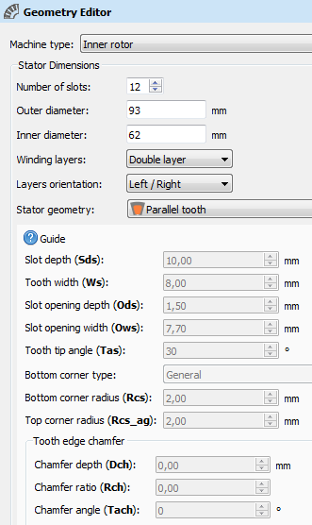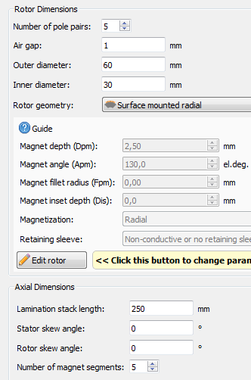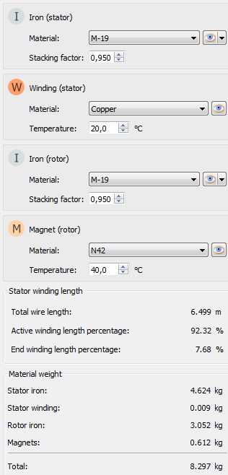

**Fig. 16:** Revised design geometrical and material properties

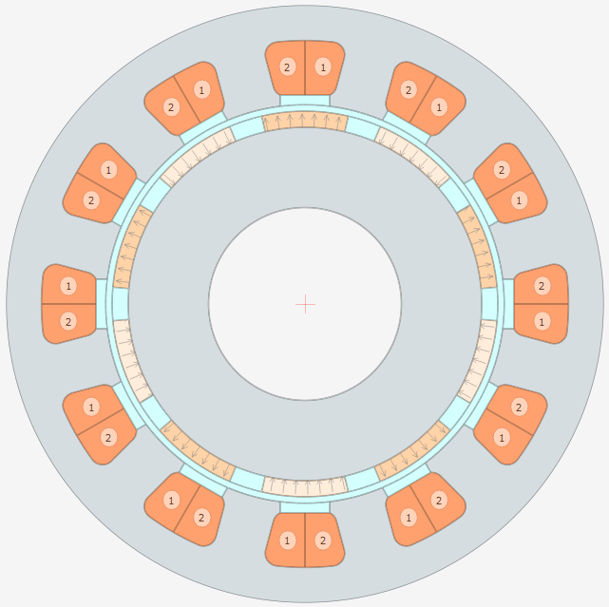

**Fig. 17:** Revised machine

The corners of the slots are smoothed, some slot openings are added. Back core thickness is increased and tooth width is decreased for keeping the slot area same as previous version. On the other hand, slot fill factor is increases from 0.6 to 0.8.

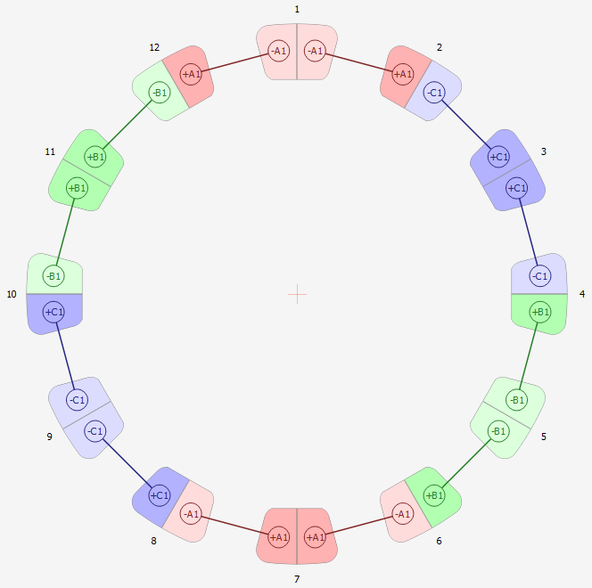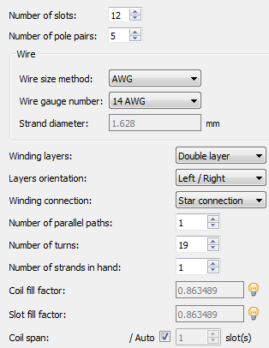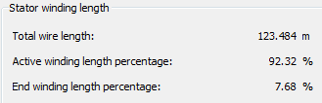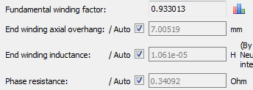

**Fig. 18:** Revised machine winding configuration and phase resistance

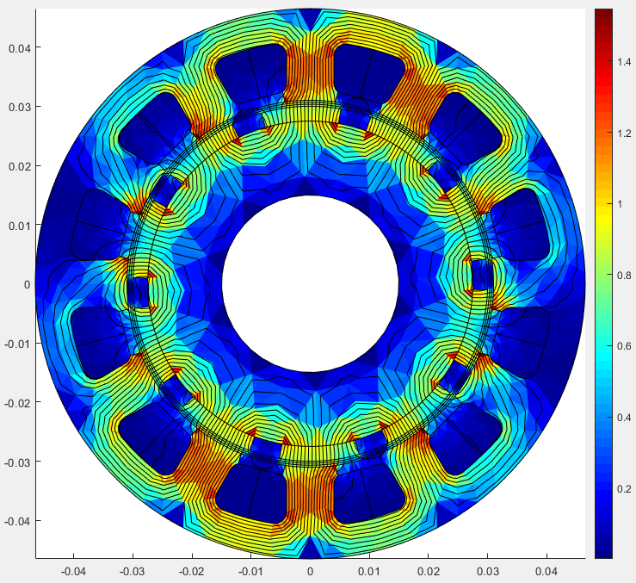

**Fig. 19:** Revised design magnetic flux density distribution

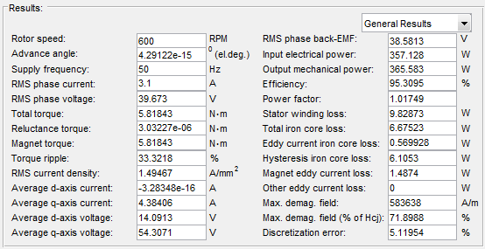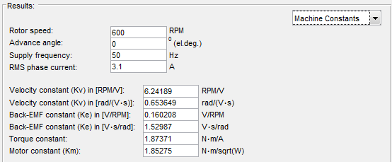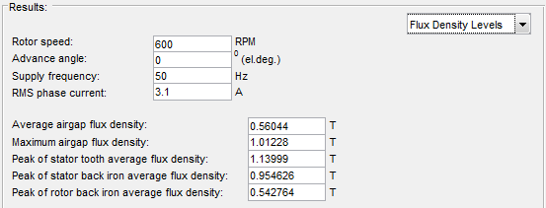

**Fig. 20:** Revised design simulation results

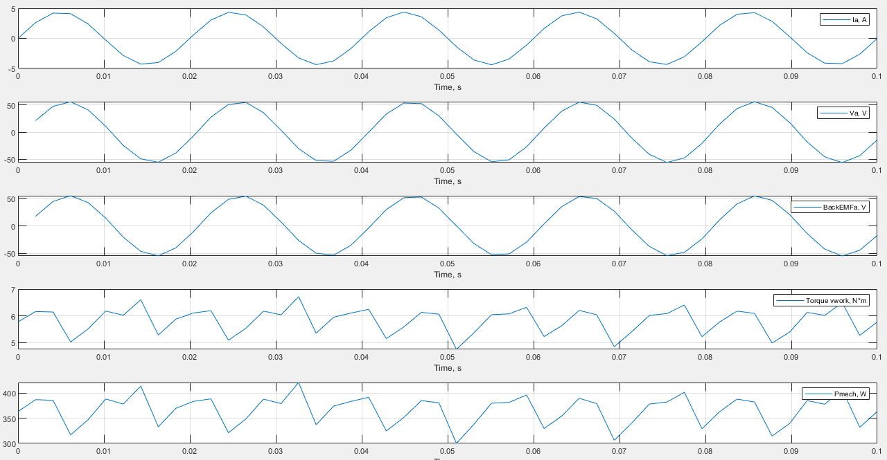

**Fig. 21:** Revised design phase A current, voltage, back emf, torque and mechanical power output

In revised design torque ripple is decreased from 40% to 33% by adding tooth leg. Also it decreases saturation level of the corner tips. Also power output level and efficiency of the machine is improved by reducing leakage flux loss.

**Design Improvements – IPM Version**

The IPM version of the designed and stator slot smoothed machine is given in this section. Stator dimensions are same as previous design but in rotor side design has some saliency. This design is done for comparing the two machine as IPMSM and SMPMSM. Preventing the leakage flux and reducing the machine weight some air gaps (1mm) are added the nearest location between two opposite polarized magnet. The design process and results are given in fig. 22-fig. 24.

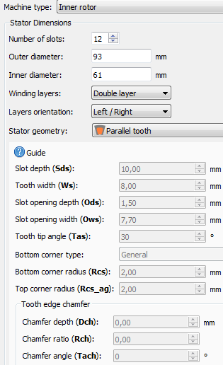 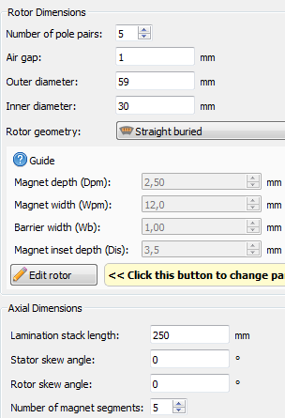 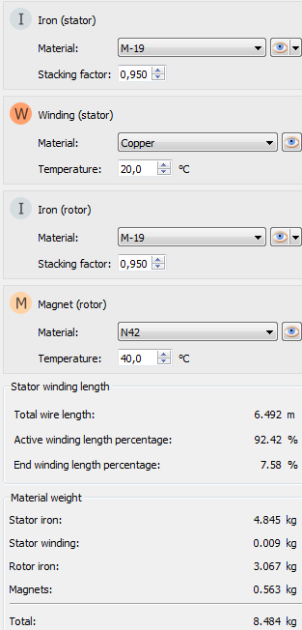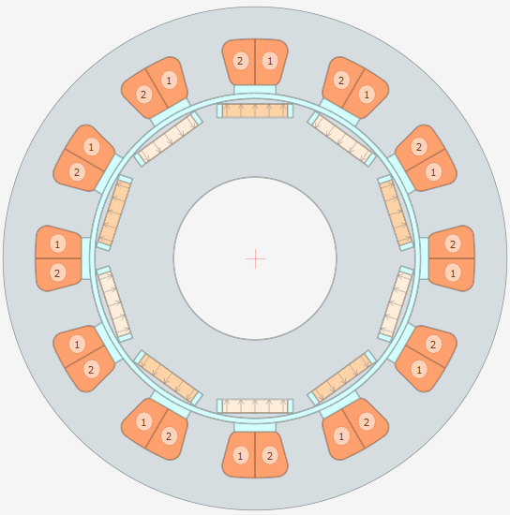

**Fig. 22:** IPM machine with same parameters

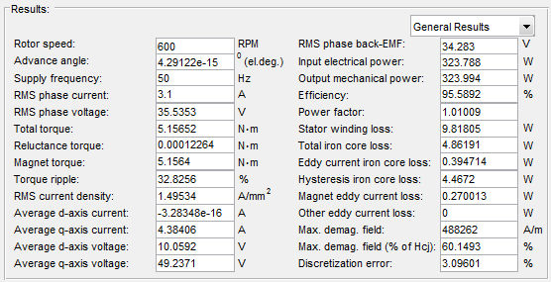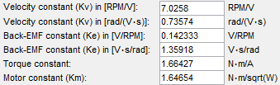 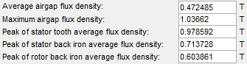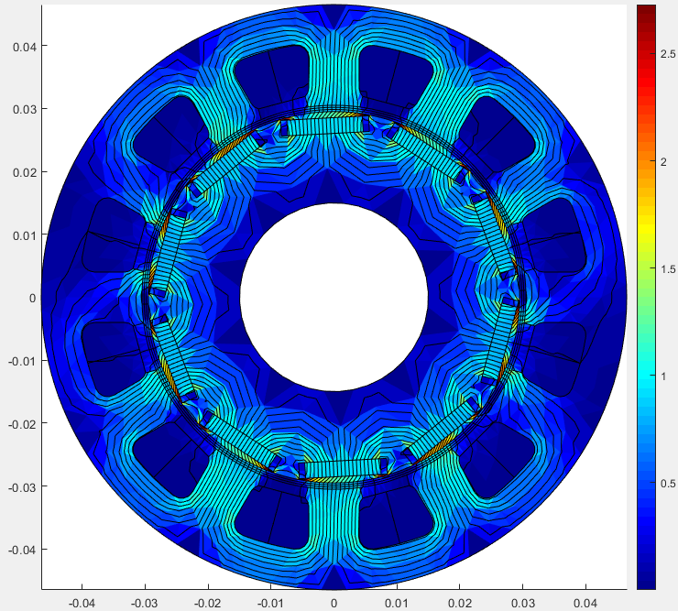

**Fig. 23:** IPM designed machine results (electrical and magnetic performance)

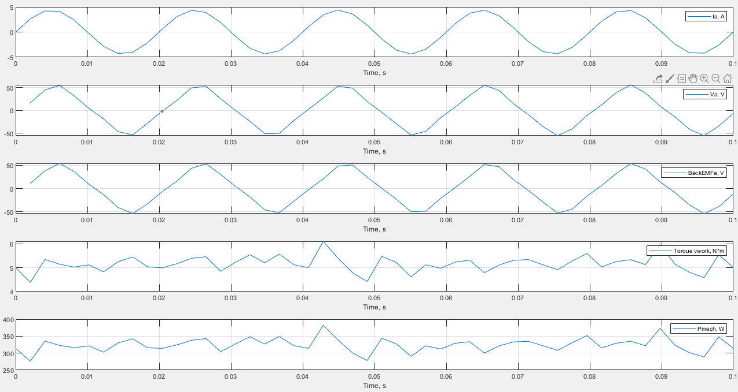

**Fig. 24:** IPM design phase A current, voltage, back emf, torque and mechanical power output

**Max. Loading & Half Loading**

The servo machine can handle a high torque (3xrated) in a short time for some applications. In the design specifications this max torque level is 12Nm at 1kW. In fig. 25-26, the max loading simulation and in fig. 27-28, half loading simulation results are given.

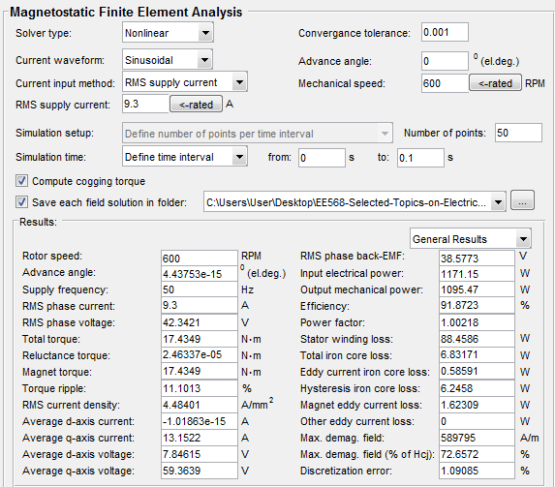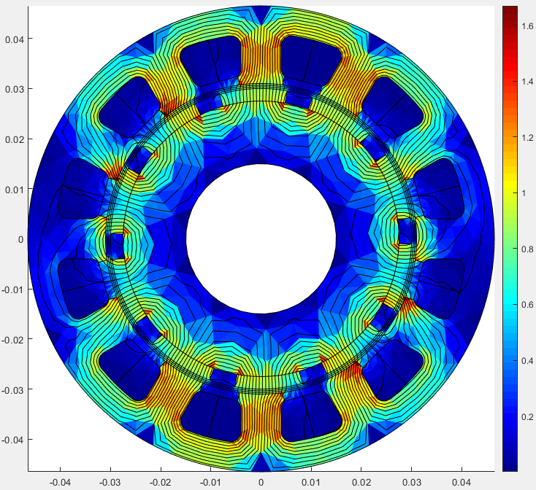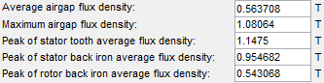

**Fig. 25:** Max loading case

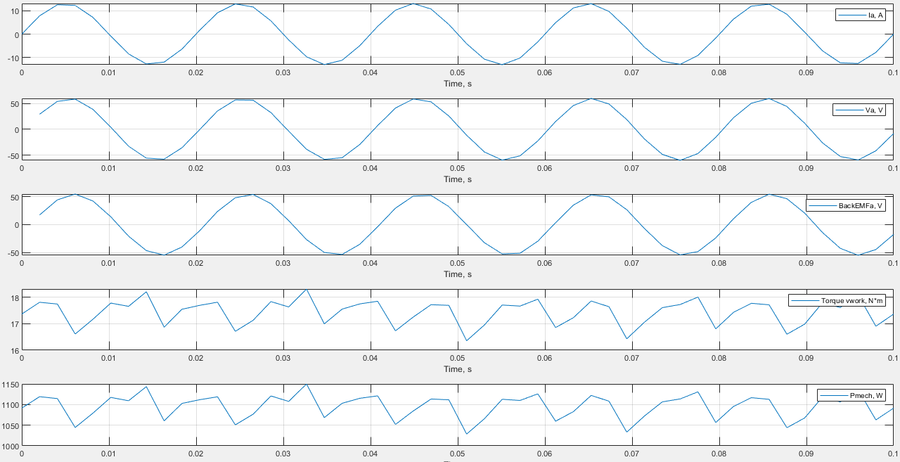

**Fig. 26:** Max loading case phase A current, voltage, back emf, torque and mechanical power output

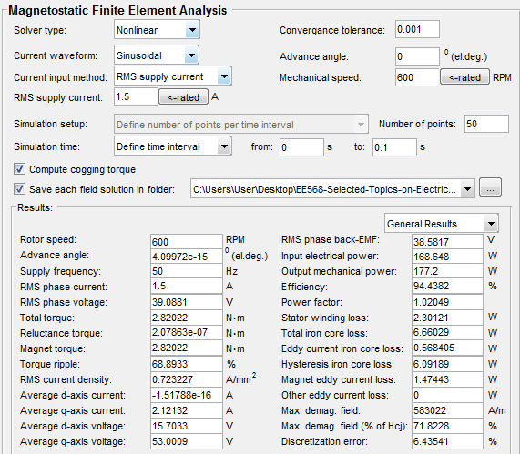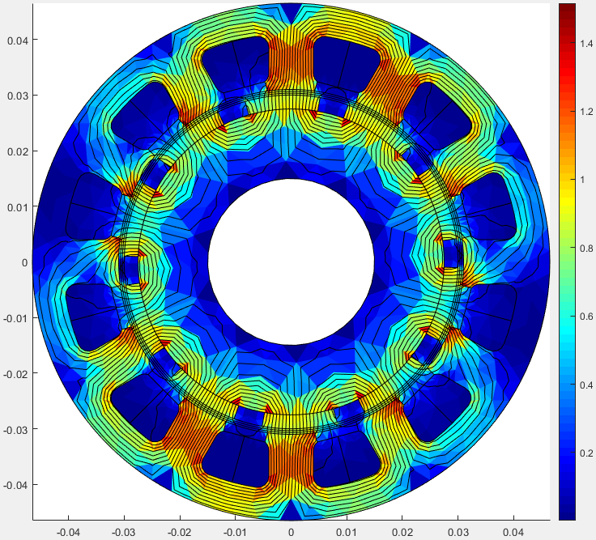 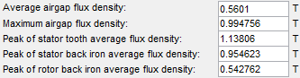

**Fig. 27:** Half loading case

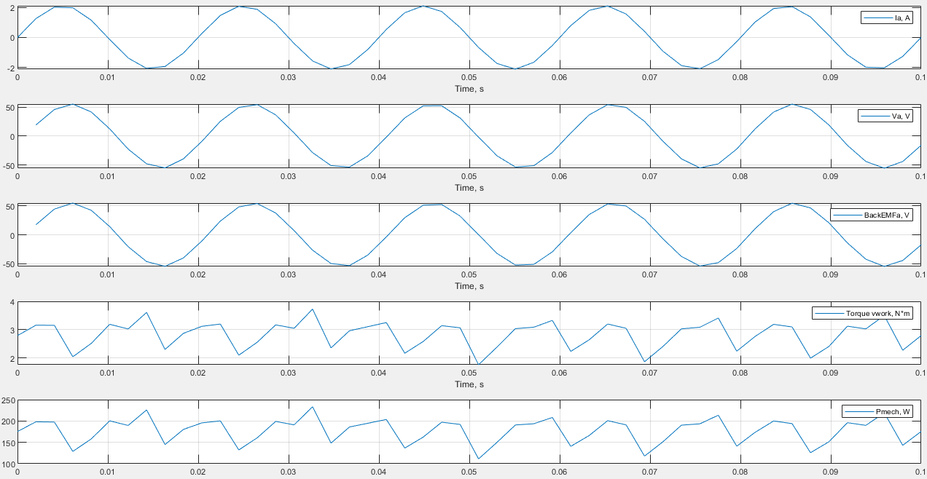

**Fig. 28:** Half loading case phase A current, voltage, back emf, torque and mechanical power output

3. Comparison & Discussion

In this section, design discussions and some comparison between designed machines are evaluated. PMSM servo design was started with determination of loadings (magnetic and electrical) and machine constant selection. This analytical computation gave us the rough dimensions of the machine. After that the critical selection was pole-slot numbers. In table 5, there are comparisons between possible pole-slot configurations. 10 pole 12 slot machine is selected, because the alternative bigger than 10 pole is not feasible in terms of magnet dimensions (too small magnets are not reachable in the market and mechanical stress resistance of them is low). 4 pole 6 slot machine winding factor is lower than the 10 pole 12 slot machine so, this means that air gap flux distribution and torque ripple would be higher than the 10 pole machine.

Table 5: Possible Pole –Slot combination comparison table

|  |  |  |  |  |  |  |  |
| --- | --- | --- | --- | --- | --- | --- | --- |
| Pole number | Slot Number | Winding factor | N turn per slot | Slot area mm2 | *Max. magnet length mm | Cogging Torque | Harmonic contents |
| 4 | 6 | 0.866 | 37 | 470 | 37.68 | High | High |
| 10 | 12 | 0.933 | 18.5 | 236 | 15 | Low | Low |
| 16 | 18 | 0.945 | 12.33 | 157 | 9.36 brittle | Low | Low |
| 20 | 21 | 0.953 | 10.57 | 134 | 7.5 brittle | Low | Low |

*magnets are located on the rotor surface ($r_{rotor}=30mm$) with 20% air clearance distance

After selection of the 10 pole-12 slot machine, the design is simulated in FEA. There are some peak saturation (1.8T is max) points (slot openings corner and back core) in the stator slots and design is revised analytically and geometrically with some trials. The machine size is not changed and comparison is given in fig. 29. The main aim is decreasing the max magnetic loading of the machine. The max torque and efficiency is obtained from 2nd design SM but slot opening tip points flux density level is 1.25T so this is theoretically suitable but machine life time will be shorter. 3rd design SM also covers the specs and efficiency value is not significantly different from 2nd design SM. Slot opening tip points flux density level is 1.14T in 3rd design SM so, it has more life time than 2nd one without any forced cooling.

|  |  |  |
| --- | --- | --- |
|  |  |  |
| Out power: 360.142 W | Out power: 392.054 W | Out power: 365.583 W |
| Torque: 5.73 Nm – 40.9%ripple | Torque: 6.24 Nm – 30.1%ripple | Torque: 5.81 Nm – 33.3%ripple |
| Efficiency: 95.03% | Efficiency: 95.45% | Efficiency: 95.30% |
| Back core flux d. 1.71T | Stator tooth flux d. 1.25T | Stator tooth flux d. 1.14T |
| 1st Design SM | 2nd Design SM | 3rd Design SM |

**Fig. 29:** Design trials for optimum design SMPMSM

Similarly, design trials are done for IPM version of this machine. The comparison is given in fig. 30. In the IPM machines magnet dimensions are kept same as SM designs. In the first design magnets are buried in rotor. Air gap is kept 1mm in the 1st design IPM. There were not used any air gap nearest of the magnets and torque performance of the design is lower than other designs also magnet edge points magnetic loading is theoretically feasible but again life time of this machine will be shorter.

|  |  |  |
| --- | --- | --- |
|  |  |  |
| Out power: 254.839 W | Out power: 372.264 W | Out power: 323.994 W |
| Torque:4.05Nm – 27.3%ripple | Torque: 5.92 Nm – 58.36%ripple | Torque: 5.15 Nm – 32.8%ripple |
| Efficiency: 95.00% | Efficiency: 95.61% | Efficiency: 95.58% |
| Air gap flux d. 0.85T | Air gap flux d. 1.42T  Stator tooth flux d. 1.12T | Air gap flux d. 1.03T |
| 1st Design IPM | 2nd Design IPM | 3rd Design IPM |

**Fig. 30:** Design trials for optimum design IPMSM

In 2nd design IPM air gap is reduced 0.5mm. At this time air gap flux density reaches 1.42T so this means that machine will hot after long time working. 2nd design IPM torque and efficiency level is high but magnetic loading level at the air gap is not suitable in terms of machine life time. 3rd design IPM is best choice (air gap:1mm) because its torque out covers the specifications and air gap flux density is feasible.

When we compare the SMPMSM and IPMSM in fig. 31, we can say SMPMSM has better performance in terms of power and torque output but IPMSM is more reliable in terms of efficiency and loading.

|  |  |
| --- | --- |
|  |  |
| Out power: 365.583 W | Out power: 323.994 W |
| Torque: 5.81 Nm – 33.3%ripple | Torque: 5.15 Nm – 32.8%ripple |
| Efficiency: 95.30% | Efficiency: 95.58% |
| Stator tooth flux d. 1.14T | Air gap flux d. 1.03T |
| SMPMSM Design 8.2kg | IPMSM Design 8.4kg |

**Fig. 31:** SMPMSM and IPMSM comparison

**Comparison with market products**

When we compare the our design machine with market products. We can see some advantages and disadvantages of our machine. In fig. 32, commercial product servo motor parameters are given from (<https://dewochina.en.alibaba.com/product/60800704570-800635551/high_performance_and_low_prices_ac_servo_motor_3kw.html>). The comparable commercial product machine is covered by red line.

When we compare the dimensions, commercial product machine Do:145, L:154 (2543cm3). Our machine dimensions are Do: 93, L:250 (1698cm3). Our machine is smaller than the commercial design. Rated torque level of our design is 18% bigger than commercial design. Commercial machine weight is 6.5kg when our SMPMSM 8.2kg, IPMSM 8.4kg. Rated power and torque of commercial design is 1kW and 4.77Nm respectively, on the other our machine rated speed at 50Hz 600rpm and that speed the power output nearly 365W at 5.81Nm for SMPMSM (IPM 323W at 5.15Nm).

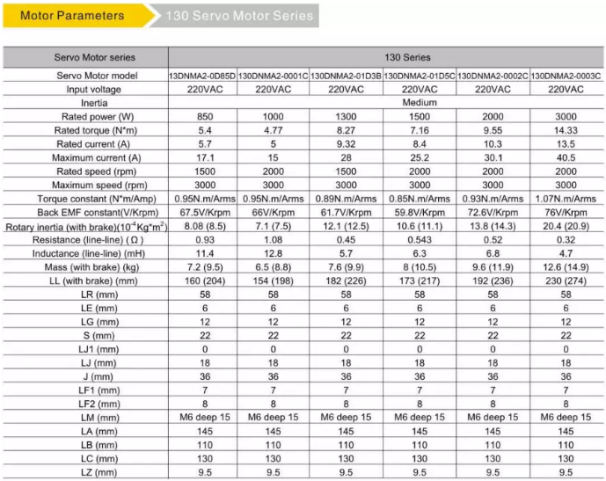 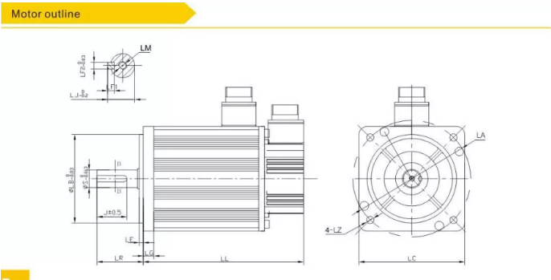

**Fig. 32:** Market product servo motors

# REFERENCES

[1] Flieh HM, Lorenz RD, Totoki E, Yamaguchi S, Nakamura Y. Investigation of Different Servo Motor Designs for Servo Cycle Operations and Loss Minimizing Control Performance. IEEE Trans Ind Appl 2018;54:5791–801. doi:10.1109/TIA.2018.2849725.

[2] Dong J, Huang Y, Jin L, Lin H. Comparative Study of Surface-Mounted and Interior Permanent-Magnet Motors for High-Speed Applications. IEEE Trans Appl Supercond 2016;26:4–7. doi:10.1109/TASC.2016.2514342.

[3] Reddy PB, El-Refaie AM, Huh KK, Tangudu JK, Jahns TM. Comparison of interior and surface PM machines equipped with fractional-slot concentrated windings for hybrid traction applications. IEEE Trans Energy Convers 2012;27:593–602. doi:10.1109/TEC.2012.2195316.

[4] Ruangsinchaiwanich S, Zhu ZQ, Howe D. Influence of magnet shape on cogging torque and back-emf waveform in permanent magnet machines. ICEMS 2005 Proc Eighth Int Conf Electr Mach Syst 2005;1:284–9. doi:10.1109/icems.2005.202531.

[5] Cros J, Viarouge P. Synthesis of high performance PM motors with concentrated windings. IEEE Trans Energy Convers 2002;17:248–53. doi:10.1109/TEC.2002.1009476.

[6] Ou J, Liu Y, Qu R, Doppelbauer M. Experimental and Theoretical Research on Cogging Torque of PM Synchronous Motors Considering Manufacturing Tolerances. IEEE Trans Ind Electron 2018;65:3772–83. doi:10.1109/TIE.2017.2758760.

[7] Dang C, Zhou W, Yin L, Tong N. Analysis and reducing methods of cogging torque on permanent magnet AC servo motor. 2014 17th Int Conf Electr Mach Syst ICEMS 2014 2014:2136–40. doi:10.1109/ICEMS.2014.7013838.

[8] Feng T, Hao S, Zhang X, Yang T, Wang L. Development of a Fault-Tolerant Permanent-Magnet Synchronous Motor. IEEE Access 2019;7:146228–39. doi:10.1109/ACCESS.2019.2945604.

APPPENDIX

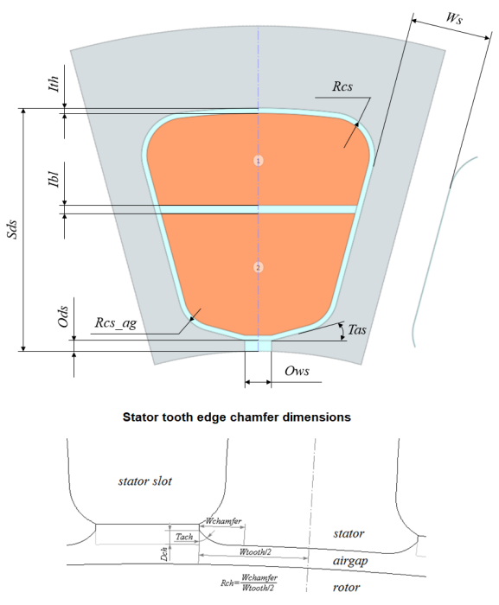

Appx. 1: Slot dimension guide

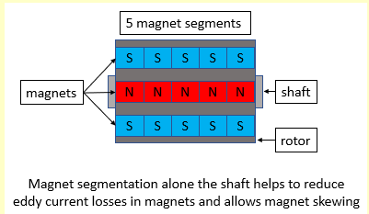

Appx. 2: Magnet segmentation number 5

Simulation files are acceptable in <https://github.com/SerhatOzkucuk/EE568-Selected-Topics-on-Electrical-Machines/tree/master/ee568_project4>